**Spreadsheet**

**Class Six**

**Lab 26**

|  |
| --- |
| Lab Objectives:  * Charts |

# How to Make a Chart in Google Spreadsheet

## Let's get back to analyzing our data on sales of chocolate in various regions to different customers. To visualize the analysis, we'll use charts.

## The original table looks like this:

## Original table

## Let's calculate the sales results of particular products by months.

## Sales by months

## And now let's present numerical data more clearly and concisely with the help of a graph.

## Our task is to analyze dynamics of sales using column charts and line charts. A bit later we will also discuss research of sales structure with circular diagrams.

## Select a range of cells for building your chart. The range should include headers of lines and columns. The headers of lines will be used as indicator names, the headers of columns - as names of indicator values.

## Besides the amounts of sales, we should also choose ranges with the types of chocolate and with the months of sales. In our example, we select the range A1:D5.

## Then choose in the menu: Insert - Chart. Insert Chart in the menu

## The chart is built, the chart editor is displayed. Google Sheets will at once offer you a chart type for your data.

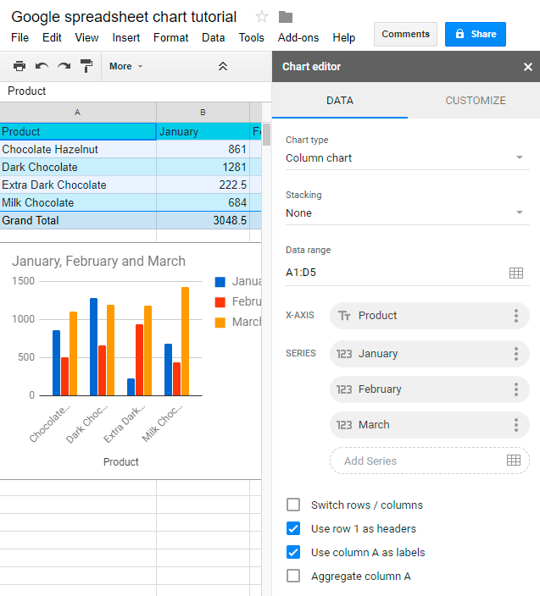

Usually, if you analyze indicators which vary over time, Google sheet will most probably offer you a column chart or a line chart. In cases, when data is a part of one thing, pie chart is used.

